

ELECTRICAL AND ELECTRONICS ENGINEERING

EE464 STATIC POWER CONVERSION 2



Team Power

Asım Reha ÇETİN – Raşit GÖKMEN– Alma PİRİC

INSTRUCTOR: Ozan KEYSAN

LECTURE ASSISTANT: İlker ŞAHİN

**Table of contents**

**1.Introduction (2)**

**2. Forward Converter Topology (2)**

2.1 Theoretical Results **(2)**

2.2 Simulation Results & Equipment Selection **(4)**

**3. Controller Design (8)**

3.1 Theoretical Results **(8)**

3.2 Simulation Results & Equipment Selection  **(11)**

**4. Demonstration Results (18)**

**5.Conclusion (18)**

**6. References (19)**

**1. Introduction**

Converters are used for changing the DC voltage level to another one and they are used widely in electronic applications. For example, voltage level of batteries in the cellphones are changed via using DC/DC converters in order to obtain different voltage levels. The other example is that line voltages in the commercial areas are converted via using AC/DC converters in order to obtain desired voltage levels. Since these converters are generally used before electronic circuits, some specific features of these converting circuits must be well designed such as efficiency, voltage ripples, harmonic component generations.

Another application of a DC/DC converter is motor drives. In this project, we designed a forward converter to drive a DC machine. Our Forward Converter has 48V input and 24V output. It has total output power flow of 100 W. Since there is always possibility of fluctuations on the input voltage level, a control circuit can be implemented to check whether the output voltage level is applicable. Because of this reason in addition to forward converter, we designed a controller circuit which keeps output voltage same even if the output load is halved or the input voltage level changed.

Moreover, after deciding circuit elements and performing necessary tests, we design a PCB circuit. It enables us to obtain more robust and stable product. In the last step we add a cooling fans in case of any heating problems. Cooling fans lead our product to work longer time periods.

**2. Forward Converter Topology**

**2.1 Theoretical Results**

Schematic of the forward converter is on the following figure 1.

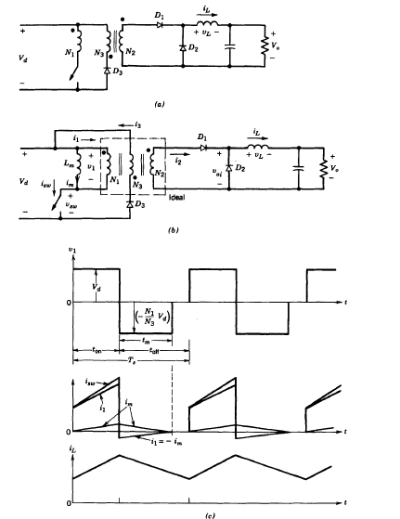

**Figure 1.** Forward converter and it’s corresponding waveforms [1] (Ned Mohan, Power Electronics)

First of all, when switch is on D1 becomes forward biased D2 becomes reverse biased. Voltage on the inductor, therefore, is

$$Vl=\frac{N2}{N1}Vd-Vo$$

When the switch is off,

$$Vl=-Vo$$

Average inductor voltage should be zero, therefore

$$\frac{Vo}{Vd}=\frac{N2}{N1}D$$

For the forward converter, magnetizing current of the transformer should be taken into account in order to obtain proper operation. One should prevent the magnetic saturation of the core in the transformer. One way to transfer the stored energy back to the supply voltage is to use practical forward converter topology which can be seen on the figure 1.

When the switch is on

$$V1=-Vd$$

When the switch is turned off

$$i1=-im$$

$$N1i1+N3i3=N2i2$$

$$i2=0$$

$$i3=\frac{N1}{N3}im$$

One needs to completely demagnetize the core which means $im=0$, minimum required of time is; [1]

$$tm=\frac{N3}{N1}DTs$$

**2.2 Simulation Results & Equipment Selection**

Simulations are created via using Matlab Simulink. Figure 2 represents forward converter.

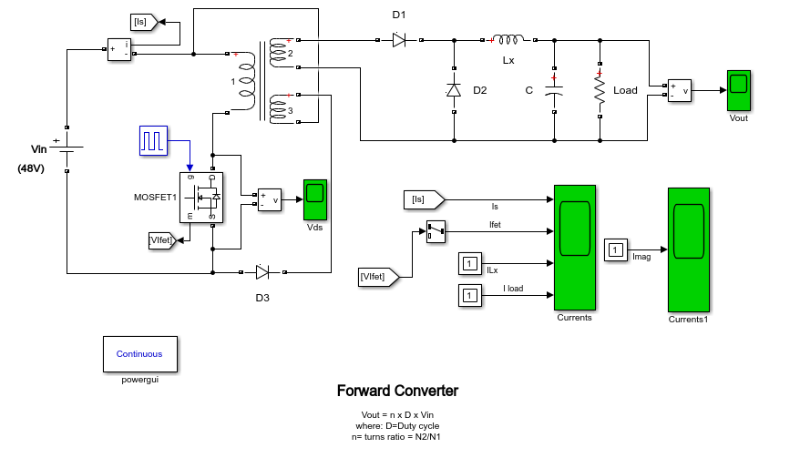

**Figure 2.** Forward Converter

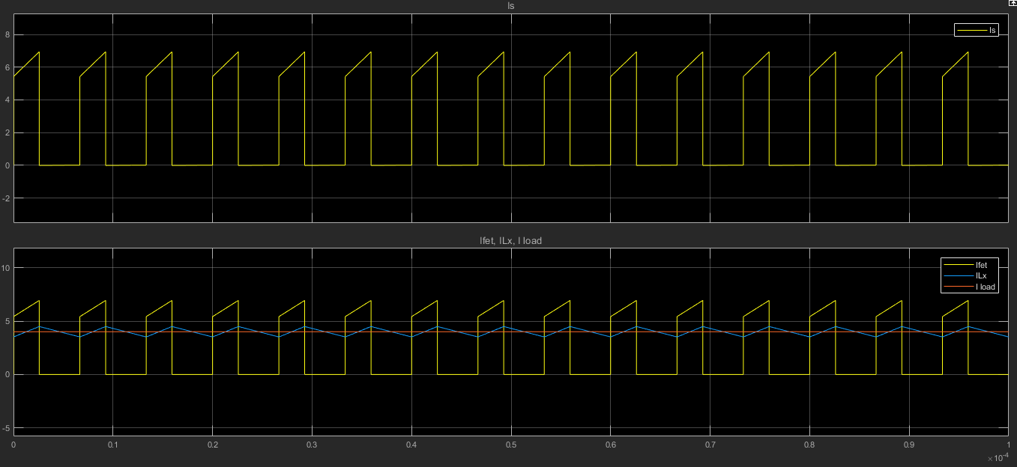

**Figure 3** : Input,Output, Output inductor and switch currents.

Duty cycle is 0.38

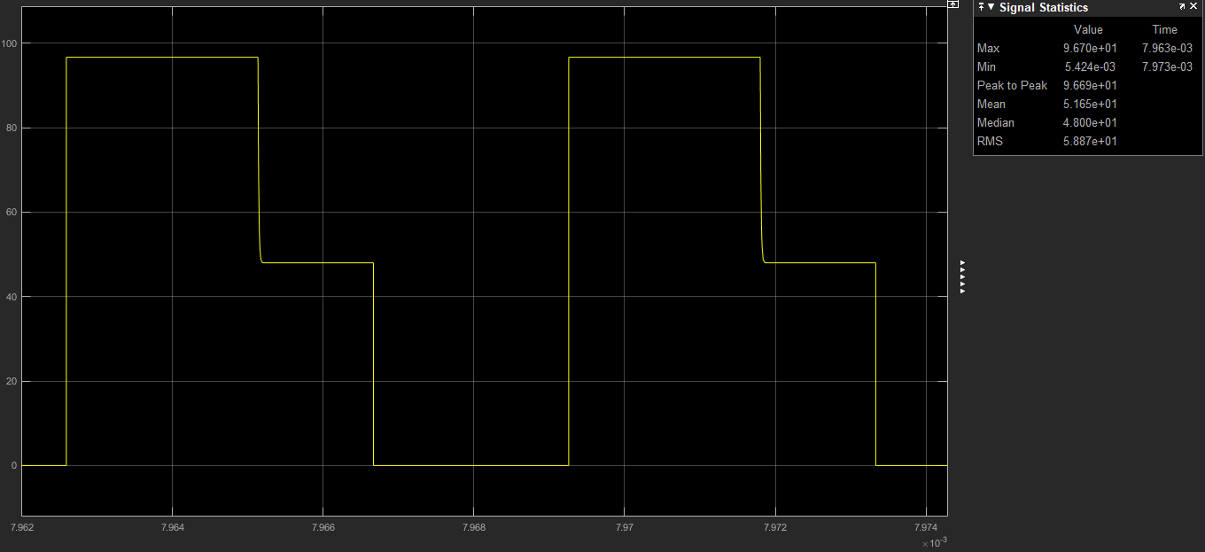

**Figure 4.** Mosfet drain source voltage.

Figure 4 represents mosfet drain source voltage. This waveform has 3 steps in one period which means core is fully demagnetizing before next operation.

**Transformer design:**

The transformer turns ratio N1/N2 is calculated 0.67. The turns ratio selected 0.6.

A ferrite core N87 with ETD39 coil former from TDK company is selected. Primary turns ratio is selected to be 6 secondary turns ratio is 10.

The core is un-gapped and its parameters given in figure 5.

Primary magnetizing inductance :

$Lm = 2700*62 = 97.2 uH.$

Minimum primary turns ratio in order to guarantee saturation:

$n1 >\frac{Vinmax*Dmax*T}{Bsat*Ae}$, $n1 = 3.77$ (our selection is 6)

For $Vimax = 53V$

$Dmax = 0.4$

$Fs = 150 kHz$

$Bsat = 0.3 T$ (max allowed core flux density for ferrites to guarantee non-saturation)

$Ae = 125 mm2$

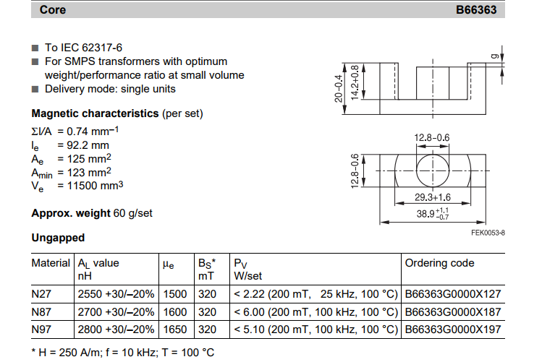

**Figure 5.** EDT39 N87 core parameters [2]

The turn ratio is wounded with litz wire which has small resistance compared with copper.

The wire is compound of 270x0.05 wire. It has 32.9 ohm/km resistance.

The mean length of one turn for our coil former is 69mm.

At primary:

$N1 = 6 turn$

$Wire length = 6*69 mm = 414 mm = 41.4 cm$

$Wire resistance = 0.414 * 32.9 *{10}^{-3}= 13.6*{10}^{-3} ohm$

At secondary:

$$N2 = 10 turn$$

$Wire length = 10*69 mm = 690 mm = 69 cm$

$$Wire resistance = 0.69 * 32.9 *{10}^{-3} = 22*{10}^{-3} ohm$$

At primary:

$N3 = 6 turn$

$Wire length = 6*69 mm = 414 mm = 41.4 cm$

$Wire resistance = 0.414 * 32.9 *{10}^{-3}= 13.6*{10}^{-3} ohm.$

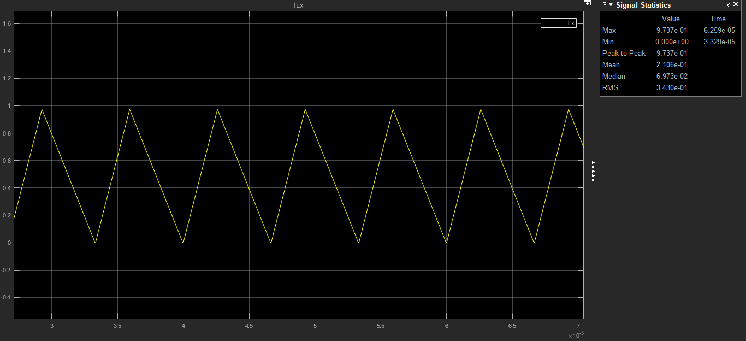

**Figure 6.** Output inductor current at boundary

**Main switch:** As a main switch STL18N65M5 is selected. It has low on resistance. It is features are given below:

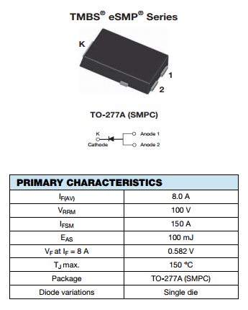

,

**Figure 7.** Main switch properties

Finally, as an **output inductor**, 47uH inductor with 8.6A saturation current from Vishay company. [3]

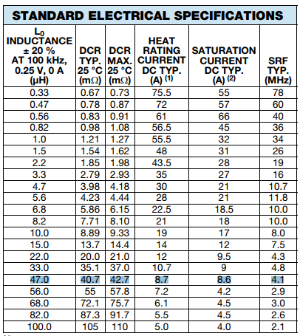

**Figure 8.** Output inductor characteristic [3]

**3. Controller Design**

**3.1 Theoretical Calculations**

Small signal analysis of the forward converter is as follows.

State equations are as follows:

On state Off state

ẋ = A1 + B1u ẋ = A2x + B2u

y= C1x y= C2x

where u is input.

Averaging them:

ẋ = [A1d +A2(1-d)] x + [B1d+B2(1-d)] u

y=C1d+C2(1-d)] x

Introducing small perturbations as follows (assuming perturbations in input is equal to zero):

x=X+x y=Y+y d=D+d

in steady state ẋ=0 and neglecting products of x and d;

ẋ=AX+Bu+Ax+[ (A1 – A2 ) X+(B1 -B2 )u]d (10-50) in text book Mohan

A = A1D + A2(1-D)

B= B1D + B2(1-D)

In steady state

AX+Bu= 0

Equation 10-50 becomes

ẋ= Ax+[ (A1 – A2 ) X+(B1 -B2 )u]d and

Y+y=CX+Cx+[(C1-C2)X]d (10-58) in text book Mohan

Where

C=C1D+C2(1-D)

Y=CX

y=Cx+[(C1-C2)X]d

Y/U=-CA-1B

Taking lap lace transform of small signal eqn. (10-58)

Y(s)/d(s)=C[sI-A]-1 [(A1-A2)X + (B1-B2)U] + (C1-C2)X

Let’s apply the formula to the forward converter state variables are defined as inductor current and capacitor voltage.

A1= [ -(R*rc + R*rl + rc*rl)/(L*(R + rc)), -R/(L*(R + rc))]

[ R/(C*(R + rc)) , -1/(C*(R + rc))]

A1=A2=A;

B1= [ 1/L ]

[ 0 ]

B2=0;

B=B1*D

For the sake of simplicity assuming R is much greater than (rc+rl);

A=A1=A2= [ -(rc + rl)/L, -1/L ]

[ 1/C , -1/(C*R)]

C=C1=C2=[rc 1];

B remains same.

A-1=1/det(A)* [-1/(C*R ) , 1/L ]

[ -1/C , -(rc + rl)/L]

Small signal transfer function is as follows

$$\frac{U\left(s\right)}{d\left(s\right)}=\frac{1+sCrc}{LC(s^{2}+s\left(\frac{1}{CR}+\frac{rc+rl}{L}\right)+\frac{1}{LC})}U$$

Gain crossover frequency is 70 000 (rad/s). Corresponding phase margin is relatively low. We need to design lead compensator here.

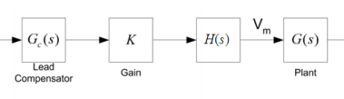

**Figure 9.** Lead Compensator design

H(s) is standing for elimination of steady state error and will be 1/s. K is gain.G(s) is lead compensator which has unity gain. It has a form of

$$Gc\left(s\right)=\frac{a\left(s+\frac{w}{a}\right)}{s+wa}$$

We obtained characteristic of $Gc\left(s\right)*\frac{1}{s}*K$ via using type 2 controller circuit. Overall open loop characteristic is

$$\frac{U\left(s\right)}{d\left(s\right)}* Gc\left(s\right)*\frac{1}{s}*K$$

**3.2 Simulation Results & Equipment Selection**

Let’s choose;

Vd=48V

Vo=28V

rl=0.085ohm

L=94uH

rc=0.00083ohm

C=60uF

R=5ohm

Fs=200kHz

$$\frac{U\left(s\right)}{d\left(s\right)}=\frac{1+sCrc}{LC(s^{2}+s\left(\frac{1}{CR}+\frac{rc+rl}{L}\right)+\frac{1}{LC})}U$$

Bode diagram is in following figure 10. Gain crossover frequency $wc=8.88*{10}^{3}$



**Figure 10.** Bode plot characteristic of open loop system.

We designed lead compensator unit here. Let’s start with integrator term in order to eliminate steady state error. Bode plot with H(s)=1/s is following figure 11.



**Figure 11.** Bode diagram of $\frac{1}{s}G(s)$

Choose K=4000; bode plot of K*H(s)*G(s) is in figure 12.



**Figure 12.** bode plot of K*H(s)*G(s)

Let’s design unity gain lead compensator at gain crossover frequency. Bode plot of single compensator is in following figure 13.

$wc=1*{10}^{4}$ rad/s

a=11;

which means we add 80 degrees phase at gain crossover frequency. Our lead compensator has a form of



$$Gc\left(s\right)=\frac{a(s+\frac{w}{a})}{s+wa}$$

**Figure 13.** Characteristic of lead compensator

Overall open loop system characteristic is in following figure 14.



**Figure 14.** Overall open loop characteristic

Figure 14 shows our closed loop system will be stable. As a result we have 39 degrees of phase margin which is enough for proper operation.

In order to control our DC/DC converter we are decided to use UC1845 Current mode PWM controller it has also current limiter. Block diagram of controller is in following figure 15.

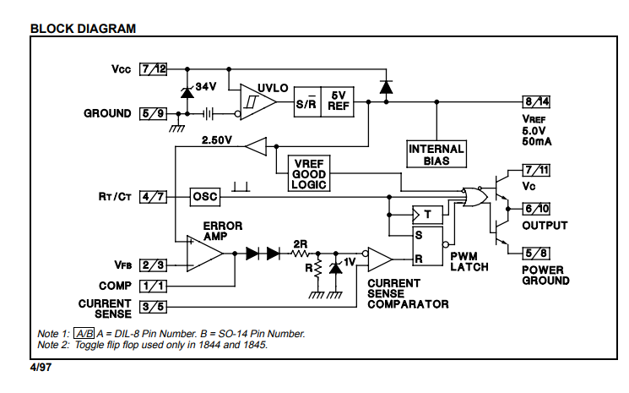

**Figure 15.** UC1845 Current mode PWM controller [4]

Typical application of UC1845 in following figure 16.

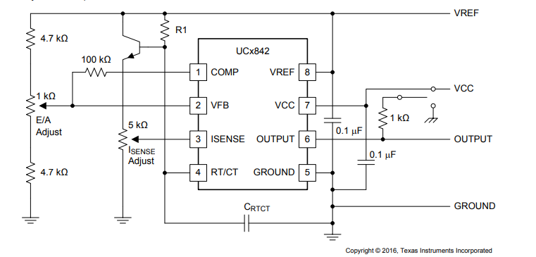

**Figure 16.** UC1845 Application

Simulation results of closed loop system are in following figure 17, 18, 19,20.

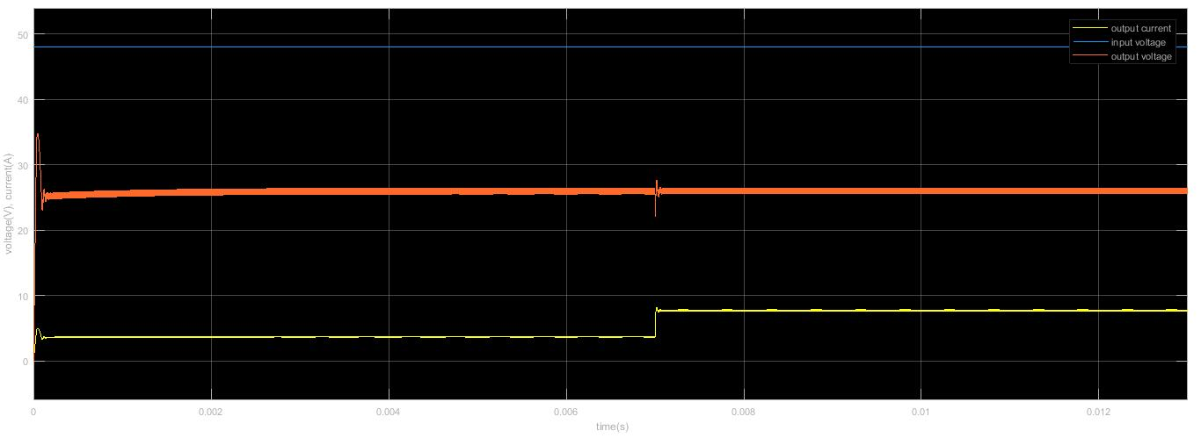

**Figure 17.** Response of the system when load is decreased two times

Control effort is in following figure 18.

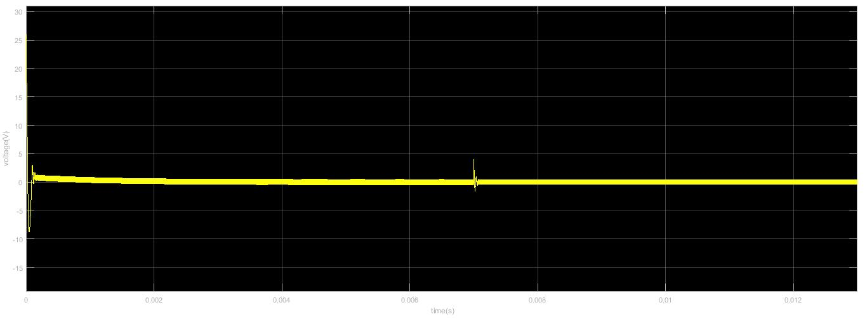

**Figure 18.** Control effort

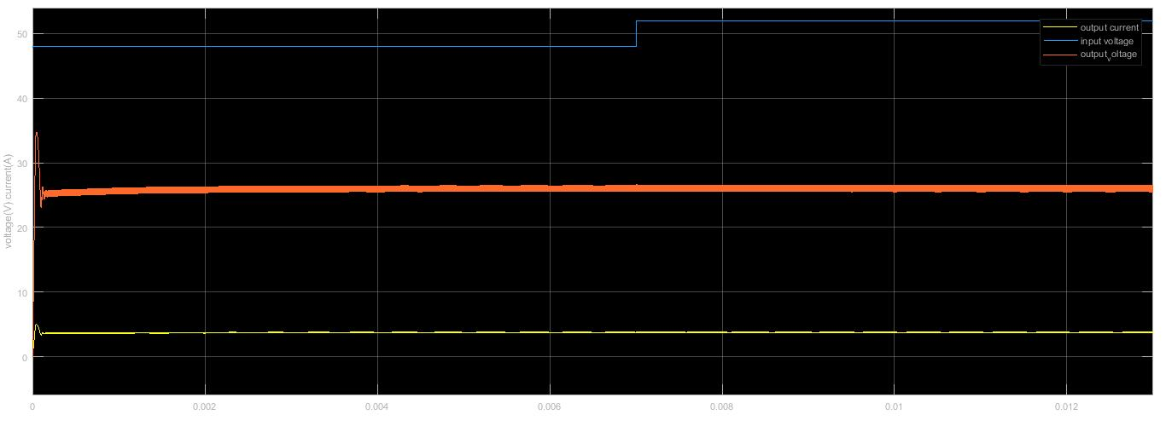

**Figure 19.** İnput voltage is increased %10

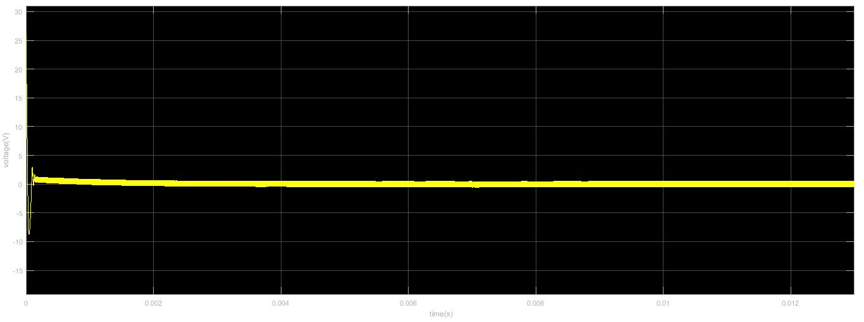

**Figure 20.** Corresponding control effort

Figure 17,18, 19 & 20show us our controller works efficiently and control effort voltage is in the applicable levels.

**4. Demonstration Results**

**5. Conclusion**

This project was a good opportunity to apply our knowledge which we gain from the course to real problem. We designed a Forward Converter and a controller circuit. We observed that in real life applications, it is not enough to have well theoretical backgrounds, there is always a possibility to encounter unexpected problems during design process. We overcome these problems by making some research on the internet (by asking people who worked on similar projects) and making some library researches. In addition to Forward converter we designed a controller circuit to stabilize the output voltage level in case of any fluctuations.

To conclude, this project was a good opportunity to check our knowledge before encountering the engineering life and we hope that solution methods and design process in this project will find an echo in the field of power electronics area.

**6.References**

**[1] Power Electronics: converters, application and design/ Ned Mohan, Tore M. Undeland, William P. Robbins. 2nd ed. New York. 1995.**

**[2] Ferroxcube inc., 2008. Retrieved From (pdf):** [**http://www.farnell.com/datasheets/1481602.pdf**](http://www.farnell.com/datasheets/1481602.pdf)

**[3] Vishay inc., Feb. 2017, Retrieved From (pdf):** [**https://www.vishay.com/docs/87532/v8pm10s.pdf**](https://www.vishay.com/docs/87532/v8pm10s.pdf)

**[4] Texas Instruments inc., Jan. 2017, Retrieved From (pdf):** [**http://www.ti.com/lit/ds/symlink/uc1845.pdf**](http://www.ti.com/lit/ds/symlink/uc1845.pdf)